## Skill-React

# React Hands-on Lab: Cricketapp

# Code:

## Terminal Instructions:

**# 1. Install create-react-app**

**npx create-react-app cricketapp**

**# 2. Move into the project directory**

**cd cricketapp**

**# 4. Open the project in Visual Studio Code**

**code .**

**# 5. Start the React development server**

**npm start**

## Code(App.js):

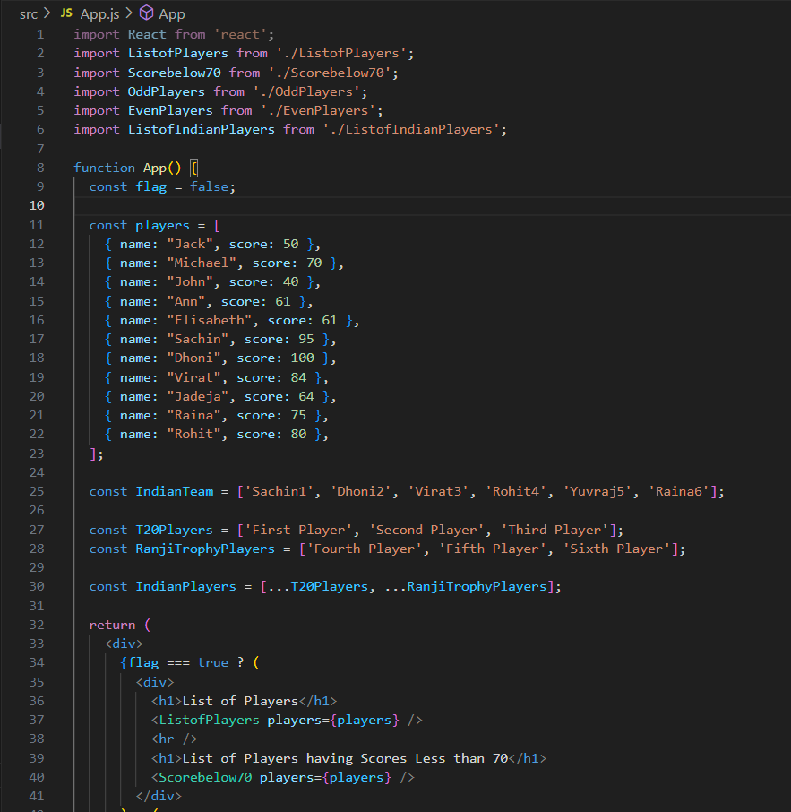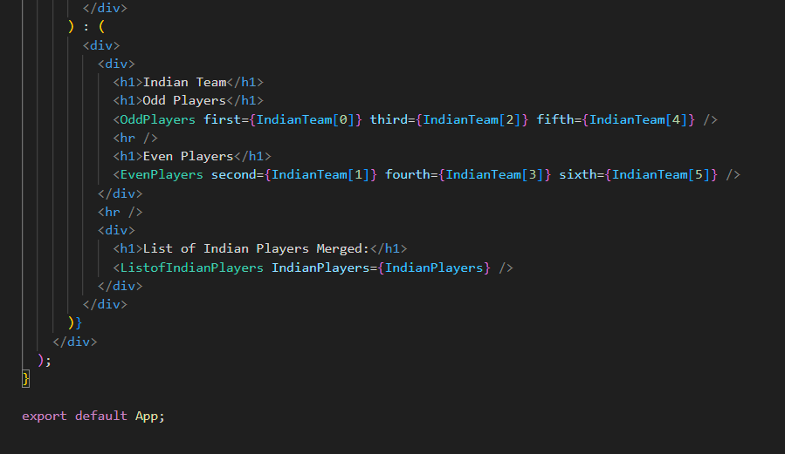

## ListofPlayers.js:

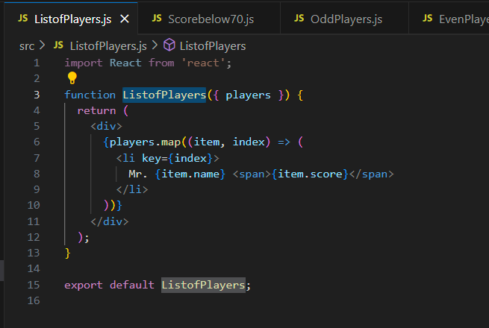

## Scorebelow70:

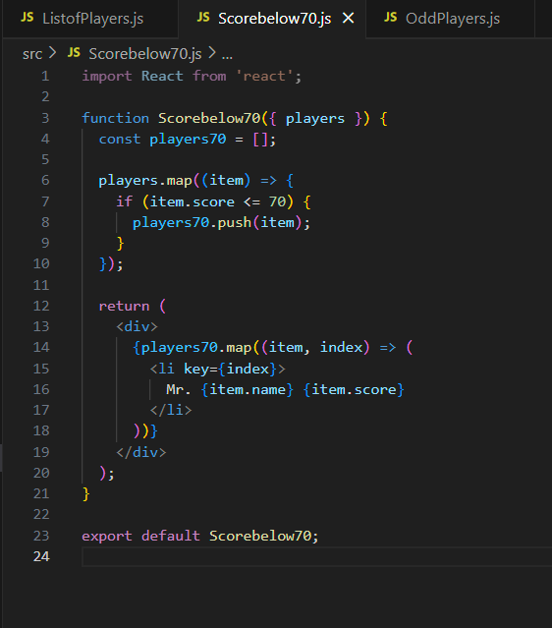

## OddPlayers.js:

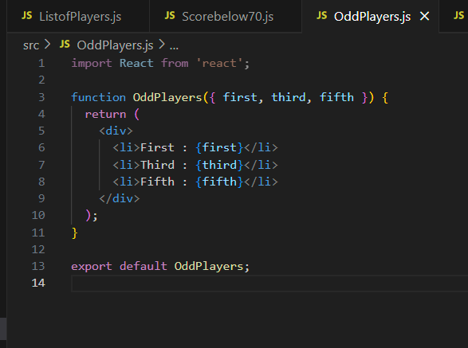

## EvenPlayers.js:

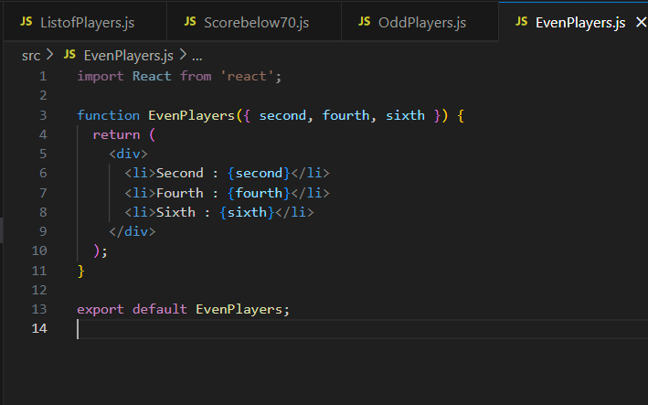

## ListofIndianPlayers.js:

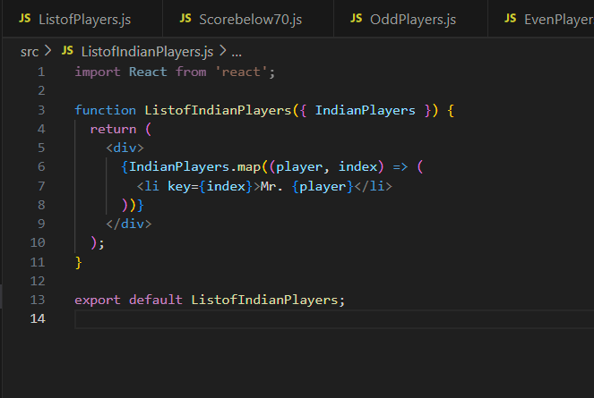

# Output:

## Flag = true :

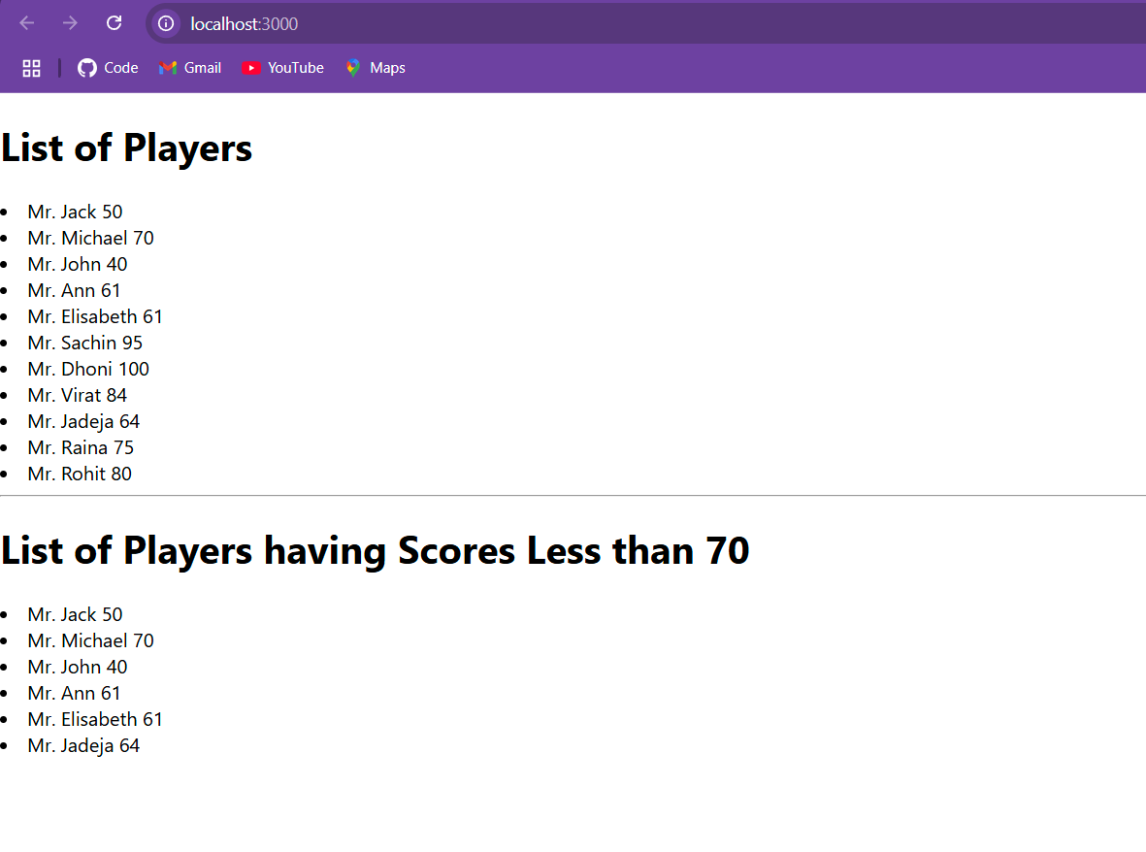

## If flag = false:

